**Mitosis – Notes**

Cell cycle:

1. G1 phase (first growth phase) – The cell produces new proteins, grows and carries out its normal tasks for the body; ends when the DNA begins to duplicate.
2. S phase (synthesis phase) – DNA molecules in the nucleus duplicate.
3. G2 phase (second growth phase) – Involves preparation of cell division.
4. M phase (mitotic phase) – The cell divides into 2 daughter cells.

Note: G1, S and G2 all occur during interphase.

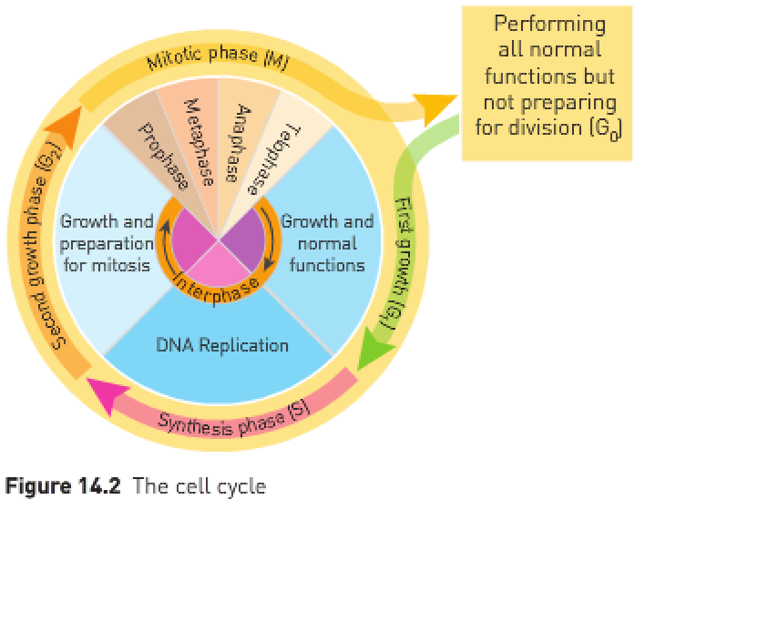

Phases of mitosis:

Interphase: – The period between nuclear divisions.  
– DNA is replicating so that there’s double the genetic information.  
– DNA appears as long, thin, uncoiled chromatin threads.  
– Cells are undergoing G1, S and G2 phases as well.  
– Not a division phase.

Prophase:

* Start of the division.
* Chromatin threads condense (coil up and become thicker) and appear as chromosomes. Coiling the long, delicate DNA molecules makes it easier to distribute DNA to the daughter cells.
* Note: A chromosome consists of 2 chromatids joined at the centre by a structure called a centromere.
* The 2 chromatids that that make up a chromosome are identical, tightly coiled DNA molecules.
* The duplicate chromatid is called a sister chromatid and is genetically identical.
* Centrioles migrate to the poles and microtubules begin to radiate from them.
* Nuclear membrane begins to dissolve (disappear).

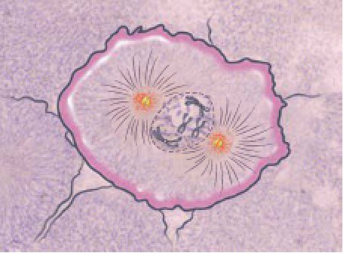

Metaphase:

* Chromosomes line up at the equator of the cell.
* Spindle fibres grow out from the centrioles and attach to the centromeres.
* Nuclear membrane has completely dissolved.

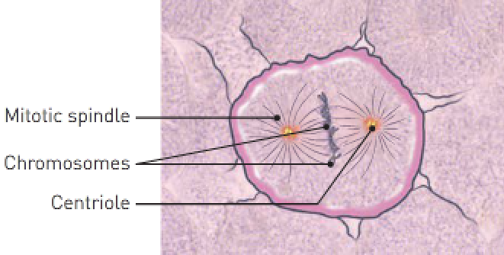

Anaphase:

* Spindle fibers retract and pull chromatids apart at the centromere into 2 identical parts towards opposite poles of the cell.
* Cytokinesis (splitting of the cytoplasm) begins.
* Split chromosomes are now called “daughter chromosomes”.

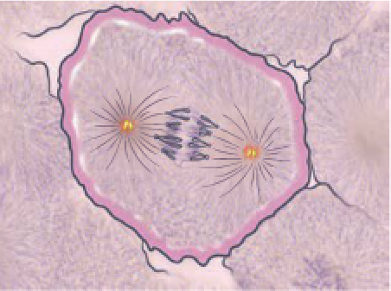

Telophase:

* Cytokinesis is completed.
* Nuclear membranes reappear.
* Nucleolus appears in each new nucleus.
* 2 genetically identical daughter cells have been created.
* Spindle fibres disappear and the chromosomes gradually uncoil to become chromatin threads once more, ready for the next replication during interphase.

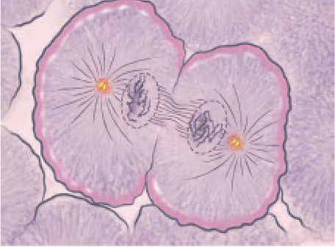

|  |  |
| --- | --- |
| **Stage**: | **Events occurring**: |
| Interphase | DNA molecules duplicate. |
| Prophase | Nucleoli disappear; nuclear membrane breaks down; centrioles migrate to opposite poles; chromosomes appear as pairs of chromatids; spindle forms. |
| Metaphase | Chromosomes line up on the spindle at the equator of the cell. |
| Anaphase | Centromeres divide; chromosomes move to opposite ends of the spindle. |
| Telophase | Spindle disappears; nuclear membranes and nucleoli form; centrioles divide; chromosomes uncoil and disappear; cytokinesis begins. |
| Cytokinesis | Cytoplasm of the cell divides into 2, each with a nucleus. |

**Meiosis – Notes**

* Purpose: To produce genetically diverse gametes.
* Meiosis results in the production of 4 haploid cells – they contain half the number of chromosomes that were present in the original cell.
* Gametes are haploid cells – they contain half the genetic information.
* The male gamete is the sperm and the female gamete is the ovum.
* When a sperm fertilizes an ovum, homologous chromosomes line up as pairs.
* Gametogenesis: The process of gamete development.
* There are 2 types of gametogenesis – spermatogenesis (formation of spermatozoa in the testis) and oogenesis (formation of ova in the ovary).

Meiosis I (first cytoplasmic division):

* Meiosis I is a reduction division – the genetic information is halved.
* Prophase I: – Chromosomes condense as DNA becomes more tightly coiled and

become visible.

* Centrioles start to migrate to the poles.
* Nuclear membrane begins to dissolve.
* The chromosomes pair off – each member of the pair are identical in size and shape and are called homologous chromosomes.
* Homologous pairs undergo a process called crossing over.

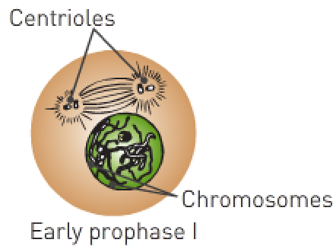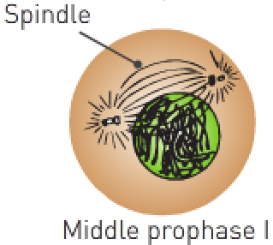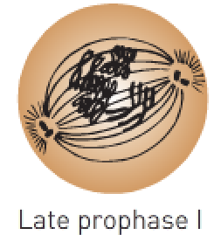

* Crossing over: – Homologous pairs (called tetrads) coil around each other.
* Parts of the maternal and paternal genetic information become mixed.
* Crossing over creates new combinations of genes so that the chromosomes passed onto the offspring aren’t the same as those inherited from the parents.
* Crossing over contributes to genetic diversity.

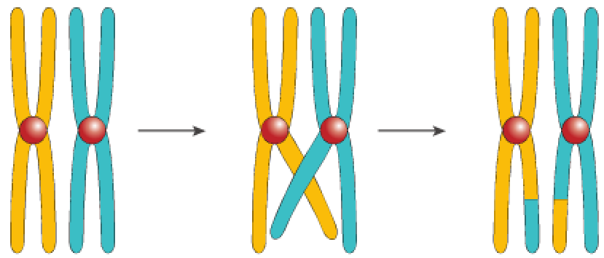

* Metaphase I: – Chromosomes line up at the equator as homologous pairs (note:

this is different from mitosis).

* Centrioles grow out spindles which attach to the centromeres.

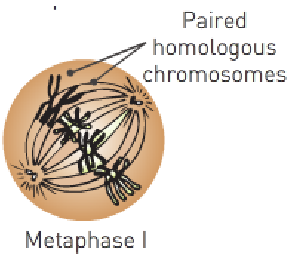

* Anaphase I: – Spindle fibres retract and pull the chromosomes to the poles.
* Note: Random assortment – the pole the chromosome moves to is random.
* 23 chromosomes move to each pole of the cell (unlike mitosis where there’s 46).
* Cytokinesis begins.

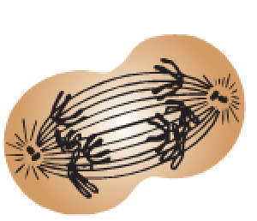

* Telophase I: – Cytokinesis completed.
* There are now 2 haploid cells containing 23 chromosomes.
* Nuclear membrane reappears.

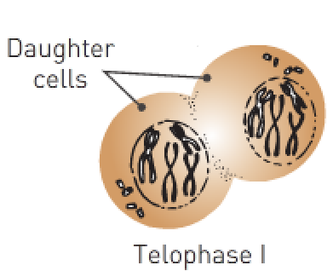

Meiosis II:

* Each daughter cell is haploid (has 23 chromosomes).
* Genetic information isn’t reduced.
* Meiosis II is similar to a mitotic division.
* Prophase II: – Nuclear membrane starts to dissolve.
* Centrioles migrate to the poles.
* A new spindle forms at each end of the original spindle and usually at right angles to the original.

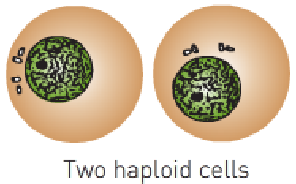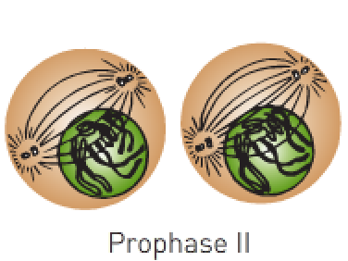

* Metaphase II: – Chromosomes line up at the equator.
* Spindle fibres grow out and attach to centromeres.
* Note: Chromosomes lined up in single file.

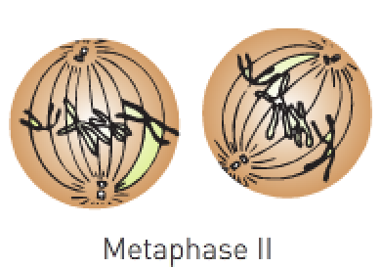

* Anaphase II: – Spindle fibres retract to pull chromosomes apart at the

centromeres.

* Spindle fibres divide so that each chromosome is now a separate chromosome.
* Cytokinesis begins.

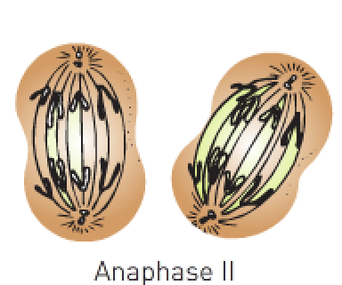

Telophase II: – Nuclear membrane reappears and cytoplasm divides.

– Cytokinesis completed.

– There are 4 haploid cells each containing 23 chromosomes.

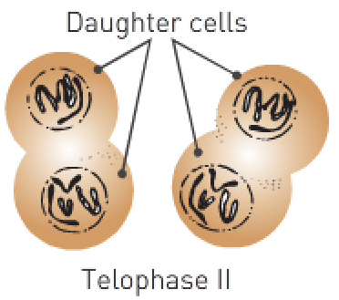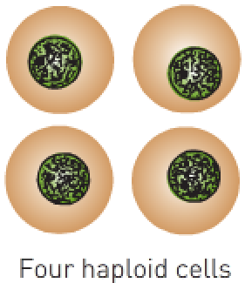

|  |  |
| --- | --- |
| **Mitosis**: | **Meiosis**: |
| One duplication of chromosomes and one nuclear division. | One duplication of chromosomes and 2 nuclear divisions. |
| Produces 2 diploid cells. | Produces 4 haploid cells. |
| Homologous chromosomes don’t pair. | Homologous chromosomes pair off. |
| Chromatids separate so that each new cell gets a complete set of daughter chromosomes. | At Meiosis I, members of homologous pairs separate so that new cells get a haploid set of chromosomes. At Meiosis II, chromatids separate, giving 4 haploid cells. |
| Chromosomes don’t change their genetic make-up. | Genetic make-up of chromosomes can be changed through crossing over. |
| Produces new cells for growth and repair. | Produces haploid gametes for sexual reproduction. |

|  |  |  |
| --- | --- | --- |
| **Phase**: | **Recurring themes**: | **Specific details**: |
| Prophase | Centrioles migrate to the poles.  Chromatin threads/chromosomes condense.  Nuclear membrane begins to dissolve. | Meiosis I: Homologous pairs and crossing over.  Meiosis II: New spindle forms at each end of the original spindle, usually at right angles to the original. |
| Metaphase | Chromosomes line up at the equator.  Spindle fibres grow out from centrioles and attach to centromeres. | Meiosis I: As homologous pairs.  Meiosis II: In single file. |
| Anaphase | Spindle fibres retract and pull chromosomes apart at the centromeres to opposite poles.  Cytokinesis begins. | Meiosis I: Random assortment. |
| Telophase | Cytokinesis completed.  Nuclear membrane reappears.  2/4 diploid/haploid cells have been created. | Mitosis: 2 diploid.  Meiosis I: 2 haploid.  Meiosis II: 4 haploid. |

**WACE Study Guide**:

Stem cell: A cell which can divide by mitosis many times and form undifferentiated daughter cells; the daughter cells can then differentiate into specialized cells.

Stem cell potency: A stem cell’s capacity to differentiate into other cell types; the more cell types it can differentiate into, the greater its potency.

Adult stem cells are cells found in a developed person which are able to divide and make copies of themselves but the copies must be able to further differentiate into cells which are more specialized; adult stem cells may be pluripotent or multipotent.

Because 50% of the sperm contain an X chromosome approximately 50% of all people born are females and because 50% of the sperm contain a Y chromosome, approximately 50% of all people born are males.

Fertilisation is the fusion of an ovum nucleus and a sperm nucleus.

Crossing over:

During metaphase I, chromatids may overlap and exchange part of their genetic material. This results in chromosomes having combinations of genetic material that aren’t present in either parent. If either of these chromosomes are involved in the formation of a zygote, genes that may not usually eb inherited together may be inherited by the new individual. Genes that are normally linked and inherited together have separated and been linked to different genes. This will cause variations in the offspring.

Random assortment:

Gametes will carry different combinations of maternal and paternal chromosomes. There are 4 types of gametes produced by this parent cell which has a diploid number of 4. Each individual, without any other changes e.g., crossing over, produces over 8 hundred million possible different gamete types. Therefore the chance of a couple producing 2 genetically identical children, unless they’re monozygotic twins, is very small.

Non-disjunction:

The spindle hasn’t successfully separated the homologous pairs of chromosomes in anaphase I. This has resulted in some gametes having more chromosomes and others having less. If a zygote has more or less than the normal number of chromosomes, this may result in the development of an individual who’s different from his/her parents.